Clerks Report – Eccleshall Parish Council meeting - 20th Sept 2023.

Supplementary documents circulated to support the agenda:
- Minutes of meetings held since the last parish council meeting and associated documents (item 8, Traffic Management, Footpaths, Enhancements, Policy & Resources and Events).
- Copy of updated Elford Heath Newt project, updated proposal (item 8)
- Responses in relation to Community Engagement poll (item 9)
- Draft revised electoral boundary recommendations (item 10)
- Community Forum flyer (item 11)
- Financial matters – monthly report and completed Annual Return (item 15)

Committee Updates (to note):

Footpaths:
- No additional report.

Enhancements:
- No additional report

Traffic Management:
- No additional report

Policy and Resources:
- No additional report

Borough Councillor Update:-
- No report

County Councillor Update:-
- No report

Liaison Reports:

Community Centre:-
- No report

Offley Hay Village Hall
- No report.

Slindon News:
- No report

Croxton:
We have finally seen the completion of the repair and restoration of the phone boxes at Croxton and Fairoak, which has been an ongoing project for the past 3 years. The traditional red phone boxes look magnificent and are being repurposed to provide a service to the local community. The Croxton box has been repurposed as a community book exchange which is now up and running. The Fairoak box will have a defibrillator installed in the coming months.
Thank you to everyone who has helped to see this project to fruition and ensure that our historical street furniture continues to provide a useful facility for the community.

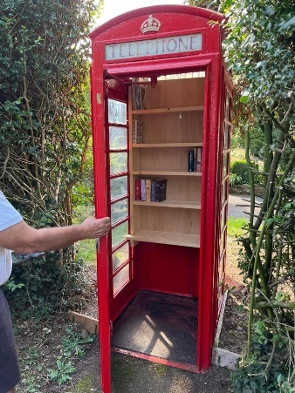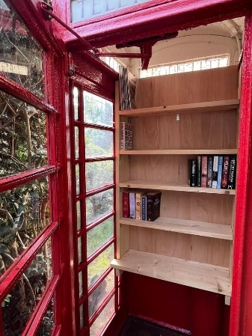

Community Transport:
- An updated leaflet promoting the scheme will be distributed in the next 6 - 8 weeks with the 26th issue of the Eccleshall Guide.

Allotments:
- No report.

Ecclian Society:-
Recent Ecclian Society activities have included:
- A Committee Meeting was held on Tuesday, August 22nd.
- The Street planting is continuing to look good and Perrys will continue to water for a two week extension to the contract. Some dead heading is planned.
- It is provisionally planned to take down the mangers, hanging baskets and flags on Sunday, October 15th.
- The Ecclian Society AGM is planned for Tuesday, November 21st at the Community Centre.
- The Society had a booth at the Eccleshall Show, which was successful and a number of new members were recruited.
- Plans for Christmas include a repeat of the bauble project with the School.
- The Christmas tree switch-on and Santa at the Lych Gate is scheduled for Sunday, December 3rd.
- There is a plan to decorate the old phone booth again with the scouts. This will use the Ecclian Society tree from the Church Christmas tree festival.
- The Eyeswell bench will be installed with an appropriate plaque.
- The 12 new posts that were installed in 2023 were all sponsored and this project will continue in 2024.
- The Open Gardens for 2024 is planned for the weekend of June 22-23 2024.

Children/Young People
- YEP has been rather quiet due to setting up the bank account, which is now complete.
- A meeting will be called in the very near future, and a fresh shout out will be made for helpers and interest.
- I have Jenny Henderson who is supporting the Asdan side of YEP. We have set a date for Sept 2023 🤞🤞to start with the Foodwise short course.
- Social media post will go out within the next week for interest.
- This will take place in the kitchen at Perrys Field to Fork.
- Thank you for the financial support.

First Responders:
- No report.

Flood Action Group:
- No report.

Other Updates:
None

Further Information to support agenda items:
No further information

Agenda item 12 – Clerks Report update:

No further updates

Correspondence information:
- No additional information

Further General Information:
- Staffordshire County Council are undertaking a campaign to publicise the availability of concessionary bus travel for older and disabled people within the county. The aim is to support the wellbeing of these people, back sustainable bus services and help to grow the economy. SCC have asked this to be brought to the attention of the Council for information and has provided posters which will be distributed on the notice boards.

Correspondence circulated:
- SPCA Weekly Bulletins
- NALC updates
- RSN Bulletins

General Council Updates:

Since the last meeting:
- No further updates
***Any items for inclusion on a meeting agenda must be received by the Clerk 10 clear days ahead of the meeting date, along with a supporting proposal where relevant.***

Abbreviations:
SCC- Staffordshire County Council EPC – Eccleshall Parish Council
SBC- Stafford Borough Council SPCA – Staffordshire Parish Councils Assc.

