Clerks Report – Eccleshall Parish Council meeting – 15th May 2024.

Supplementary documents circulated to support the agenda:
- Current Committee and Liaison Representatives list (item 6)
- Policies to be reviewed/adopted (item 8)
- Minutes of meetings held since the last parish council meeting and associated documents (item 11, Footpaths, Events).
- Forward Plan (item 14)
- Library Risk Document (item 15)
- AGAR documentation (item 19)
- Financial Report (item 19)

Committee Updates (to note):

Footpaths:
- No additional report.

Enhancements:
- No additional report

Traffic Management:
- No additional report

Policy and Resources:
- No additional report

Borough Councillor Update:-
- No report

County Councillor Update:-
- No report

Liaison Reports:

Community Centre:-
- No report.

Offley Hay Village Hall
- No report.

Slindon News:
- No report

Croxton:
- A few of the reported potholes have been filled but the flood on Croxton Lane remains - still with flood warning signs and no attempt by SCC Highways to unblock the drain. The flood has now been in place for FIVE months. Totally unacceptable!
- Broughton Parish Room has had new double glazed windows fitted today (29.4.24), with a supporting grant from SBC. This should enable much improved retention of heat in the Room and less wasted energy:
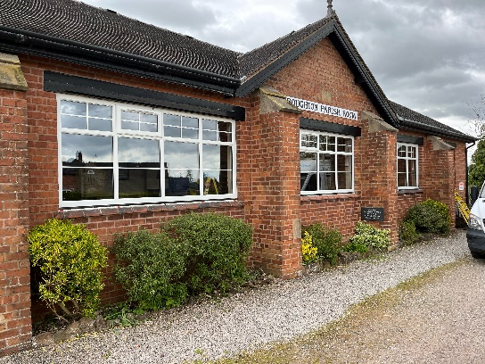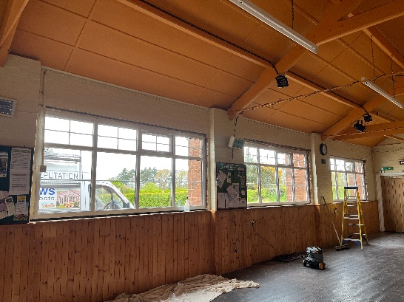
- A dreadful car accident on the evening of 11th April demolished two parked cars at the Broughton Parish Room (both cars have been written-off), …. and by the Grace of God no one was injured! The car was speeding and lost control, - wiping out a garden hedge, telegraph pole and flying through the air landing and crushing 2 parked cars (one with an elderly lady inside). Residents and users of the BPR are requesting SCC to put in place improved road safety measures through Wetwood where the derestricted B5026 road passes through the village, - passing the BPR community hub and two staggered junctions. Speeding is a problem and fatalities have previously occurred on this section of the B5026 at Wetwood … causing pedestrians and users of the BPR and vehicles crossing at the junctions to be put in danger. We are asking for EPC to support us in lobbying SCC to improve road safety measures at Wetwood. SCC Councillor J. Pert has been contacted by many concerned residents.
- Planning for the 2025 Croxton Well Dressing begins this month with Saturday 5th July as the date of the Community Well Dressing Festival to be put into diaries.

Community Transport:
- No report.

Allotments:
- The Parish Council has received the annual rent, based on current plot occupancy, which for 2024 is £575.75.

Ecclian Society:-
Recent activities have included:
- The Spring Newsletter, which was distributed to all Eccleshall households produced excellent feedback. It helped to add a number of new members and sponsors.
- Plans for Open Gardens on June 22-23 are being progressed by Luke and Anne Serjeant. We would still like to add more gardens and are looking for people to help man the sales desk outside the library on the Saturday and Sunday.
- Refreshments will again be provided at Ashcroft on Stafford Road thanks to Gill Bertram
- The 2024 Eccleshall Calendar proved very popular and made a good profit for the Society.
- Thanks to Richard Egan’s organisation, a further nine stainless steel anchors were installed by Amey recently and the oak posts will be installed soon.
- The mangers and hanging baskets are due to be erected on Sunday, June 2nd.
- Sponsorship requests have been sent out regarding the Summer planting and hopefully the QR code and direct link will make it easy for people to respond.
- New troughs are planned for the Welcome to Eccleshall sign on the Chester Road and will be planted up after the sign is reinstalled. A further trough will now be required for the Newcastle Road sign to replace the one destroyed this last weekend.
- An Ecclian Society/ Bloom Committee meeting is planned for Tuesday, May 14th..

Children/Young People
- No report.

First Responders:
- No report.

Flood Action Group:
- No report.

Other Updates:
None

Further Information to support agenda items:
Police statistics, item 10. – crime information can be viewed at https://www.staffordshire.police.uk/. Enter your postcode and click on the crime map to drill down to specific locations and types of crime. PCSO Lisa Powell has confirmed that the ward boundaries differ between the parish council and the police, so any reports will not match our areas and will be misleading. This will be the best way for members to view where the crimes are located.
If you have any specific questions about an incident, raise them in advance or at the meeting. However - Lisa covers a wide policing area so would need to review the incident in question and is unlikely to be able to answer specific queries without prior notice. Lisa has also noted (after checking with a superior officer regarding what she can share) that there may also be GDPR issues in disclosing certain details about crimes – for example going into details of where a theft occurred could result in disclosing the person/address it relates to.

Agenda item 8– Policy updates
- Publication Scheme – to update on publications currently available (inclusion of new walks publications)
- Risk Assessment Summary – new document that supercedes the Financial Risk Assessment, to provide a simplified document that also expands the scope to encompass non financial risks.
- Note – all policies that contain a PC contact email have been updated to reflect the new email address and will be uploaded to the website in due course.

Agenda item 12 – Clerks Report update:
- No further updates

Correspondence information:
- No additional information
Further General Information:
- No additional information

Correspondence circulated:
- SPCA Bulletins
- NALC updates
- RSN Bulletins

General Council Updates:

Since the last meeting:
- No further updates
***Any items for inclusion on a meeting agenda must be received by the Clerk 10 clear days ahead of the meeting date, along with a supporting proposal where relevant.***

Abbreviations:
SCC- Staffordshire County Council EPC – Eccleshall Parish Council
SBC- Stafford Borough Council SPCA – Staffordshire Parish Councils Assc.

