Clerks Report – Eccleshall Parish Council meeting – 18th March 2026

Supplementary documents circulated to support the agenda:
- Minutes of meetings held since the last parish council meeting and associated committee documents (item 7, Events and P&R)
- Additional donation request (item 7)
- Footpaths Diversion request (item 7)
- Biodiversity Working Group notes (item 8)
- Financial reports (item 14)

Footpaths:
- No additional report.

Enhancements:
- No additional report.

Traffic Management:
- No additional report

Policy and Resources:
- No additional report

Borough Councillor Update:-
- No report

County Councillor Update:-
- No report

Liaison Reports:

Community Centre:-
- No report

Offley Hay Village Hall
- No report.

Slindon News:
- No report.

Croxton:
- Following continued non-compliance to cut-back a hedge overhanging the footpath and onto the B5026 in Croxton the hedge has now been trimmed back.
- Removal of an EPC footpath finger post to a walk from Woodwall Green down to the Langot Valley was reported to the Clerk. (Clerks note – under investigation).
- Litter thrown from vehicles and traffic lights signs dumped along the verges and lay-by alongside (a) the B5026 approaching Croxton and (b) the approach to St Peter’s Church, Broughton has been reported to Street Scene.
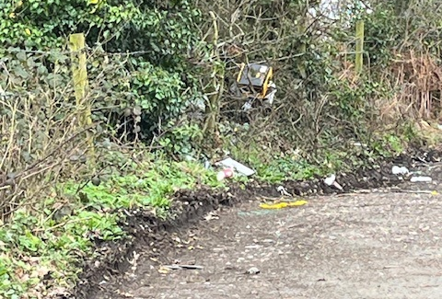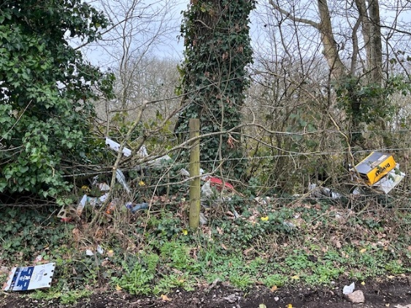
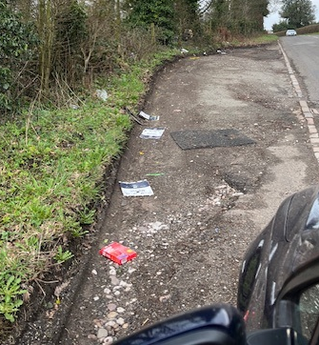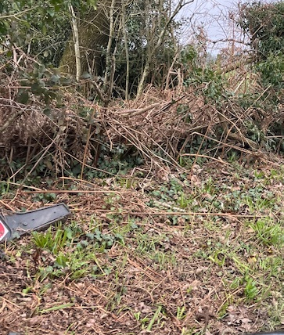

- Repeated blockage of a pipe carrying a stream below Croxton lane causing flooding to nearby fields and private property (possibly criminal damage) was reported to the Clerk, Highways and Cllr J.Pert.
- The remaining pothole at the edge of a BT inspection cover by the road outside the entrance to Broughton Parish Room has been repaired by BT when work took place at the X-roads recently to upgrade the area to 5G.
- Leaflets were distributed to residents of Croxton, Wetwood, Fairoak etc. re the proposal by Atlas to erect a phone mast in Croxton to improve connectivity in the area.
- St Paul’s Church is still interregnum and reported in the ABC magazine as at risk of closure.
- Large, damaging potholes (reported to Highways for over 12 months) on several of the rural lanes around Croxton remain unrepaired and classified as non-urgent!!
- B5026 road surface from Sugnall X-roads to Croxton (reported continually to Highways) continues to be in a very poor state partly because it was not resurfaced for some reason when the rest of this road was done 3 years ago. Cllr. Pert has reinforced the urgency of need for repair / resurface of this section of the road.
- More near-misses at the Wetwood crossroads have been reported this week on social media with further comments about risk to both pedestrians and and vehicles when crossing / turning onto the B5026 with traffic approaching at 60mph. Speed restrictions / reduction infrastructure is urgently needed here before another fatal accident occurs.

Allotments:
- No report

Ecclian Society:-
- The Committee meeting was held in the community centre in the Jubilee Room on March 3rd. The Community Centre is now being utilised as HQ for the society with all 2026 meetings already booked.
- The new look membership leaflet will be available this month from the library.
- The Ecclian Society walking group is being resurrected and will be operational for the Summer, dates TBC.
- We have started a Remembrance Day poppy project, and all Eccleshall groups and committees are welcome to contribute. We require 1000`s of handmade poppies to produce a cascading net. So far, The Ecclian Society Committee, Bishops Lonsdale School, The WI and Eccleshall 1st Scouts are busy making poppies.
- Our fresh new look spring newsletter will also be delivered to all households in Eccleshall this month.

Eccleshall Voluntary Car Scheme
- No report

Children/Young People
- No report.

First Responders:
- No report.

Flood Action Group:
- No report.

Other Updates:
None

Further Information to support agenda items:
No further information.

Agenda item 10 – Clerks Report update:
- No further updates

Correspondence information:
- No further information

Further General Information:
- No further information

Correspondence circulated:
- SPCA Bulletins
- NALC updates
- RSN Bulletins

General Council Updates:

Since the last meeting:
- No further updates
***Any items for inclusion on a meeting agenda must be received by the Clerk 10 clear days ahead of the meeting date, along with a supporting proposal where relevant.***

Abbreviations:
SCC- Staffordshire County Council EPC – Eccleshall Parish Council
SBC- Stafford Borough Council SPCA – Staffordshire Parish Councils Assc.

